South Area Advisory
General Meeting – Minutes Draft
Wednesday, May 19, 2021
6:30 pm Virtual Meeting
http://southareaadvisory1.ch2v.com/

Welcome 06:33 PM EST

Attendance Form: https://forms.office.com/Pages/ResponsePage.aspx?id=y7Ws7nBTWEOpaqN4PJXUIuscdyxkjwtKpUjpDacxlBNUNTI4MFQxTlFXSlpIWEYzN0w3WDZLQzZROS4u

Legislative Affairs
John Sullivan – Director
Angel Gomez – Governmental Affairs
- SB 590 – School Safety effective 07/01/21
- HB7045 – School Choice effective 07/01/21
- SB 1028 – Charter Schools effective 07/01/21
- HB 149 – Students with Disabilities in Public Schools 07/01/21
- HB173 – IEP Requirements for Students 07/01/21
- HB 241 – Parents Bill of Rights 07/01/21
- HB 7061 – Taxation from July 31st to August 9th.
- Full PowerPoint and details can be found in this link: https://legistarweb-production.s3.amazonaws.com/uploads/attachment/pdf/920454/Third_School_Board_Workshop_May_13__2021.pdf

School Counseling & BRACE Advisement
Ralph Aiello – Director
- College & Career Readiness
  - Florida Bright Futures extended until December 1st to qualify
    - If you qualify after it will be rewarded retroactively
    - Waived Community Service Requirement
    - You must apply by August 31st.
  - FAFSA
  - Next Wednesday, discussion on transitions
    - School Counseling & BRACE Advisement / College, Career, & Life Readiness (browardschools.com)
- 6000.1
  - Interim Reports
    - Updating language for elementary schools
    - Better to review through Pinnacle
    - Policy describes who will be getting them
    - Know they need to work on procedure so that everyone gets them
  - Multi-Tiered Systems of Support
    - Team is working to update language throughout the report
  - Students with Disabilities
  - 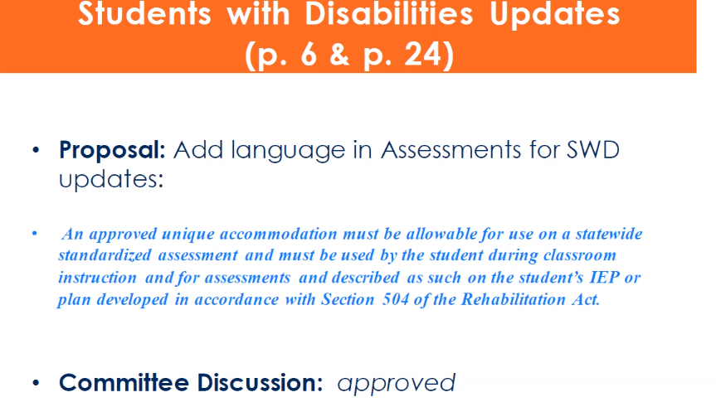
  - Appendix A
    - Language in Appendix A, regarding elementary good cause promotion, will need be updated.
  - Middle School Credit Recovery
    - Proposal to explore alternative middle school credit/course recovery criteria
  - Financial Literacy & FAFSA Requirement
    - 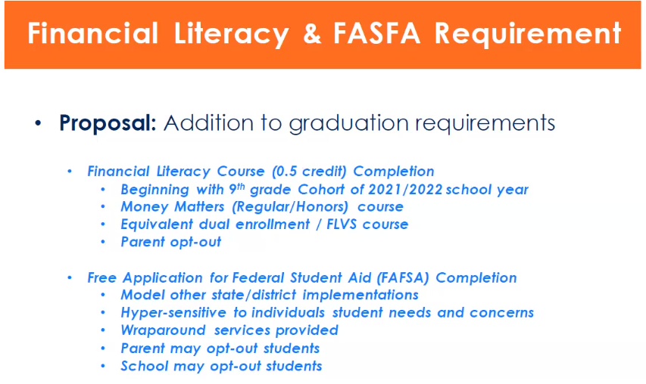

- Policy 6000.1, under exam exemptions: - AP/IB/AICE midterms cannot be exempted; however, the student may exempt the final exam.
- - Teachers are encouraged to give an alternative assessment in lieu of a
- traditional final.
- Homework Policy
  - Change language in HW Policy 6306 to bring it up to date

Secondary Learning Department
Guy Barmoha – Director
- Summer Experience (Browardschools.com/summer2021)
  - 85 Sites are now open
  - You can register on your own school sites
  - Lunch and transportation will be provided
  - Elementary – Project based on the Environment and making a greener Earth
  - School Counselor will also be available
  - Various electives are being offered – Art / STEM / Music / PE / Debate
  - Academic Enrichment courses will be also available
  - Middle School & HS Students will get credit for the Academic recovery courses
  - Parent University on May 24th will go in more detail about the summer experience - Parents & Families / Parent University (browardschools.com)

OSPA- Office of School Performance and Accountability
Scott Jarvis
Donna Boruch
- https://www.browardschools.com/Page/35378 Locate the SIP Information Guide for Quarter 4 here.

Policy 1.7
Linda Ferrara
- Policy 1.7 SCHOOL BOARD-ESTABLISHED ADVISORY COMMITTEES AND APPOINTMENT OF A SCHOOL BOARD MEMBER REPRESENTATIVE(S) TO SUCH COMMITTEE(S)

Legislative Updates
Carmelo Borges

Old Business

New Business
Slate of Officers listed below.

District Advisory Council Report
- http://browarddistrictadvisory.ch2v.com/Content/22_429/DocumentStore/36/DAC%20Minutes%205.12.21%20DRAFT%20.pdf

Public Input

Adjourn 08:41PM

Upcoming meetings District Advisory Council June 2, 2021 6:30 pm
Please note we will be meeting in person to hold elections.
Gifted Advisory Council June 7, 2021 7 pm

Have a safe and relaxing summer!

South Area Advisory Council
Slate of Officers
For 2021/22

Chairperson: Veronica Newmeyer_______________________________________________________
Vice Chair Elementary: Christina Kim_____________________________________________________
Vice Chair Secondary: __Laurel Garfinkel__________________________________________________
Recording Secretary: _____________________ __________________________________________
Corresponding Secretary: ___Carmelo Borges___________________________ ___________________
District Advisory Council Representatives
Parent At Large: __Christina Kim_________________________________________________________
2 Elementary School Reps: 1) Coralina Quezada 2) __Elizabeth Smith__ _________ ___
2 Middle School Reps: 1) 2) _____________ ______ _ ___
2 High School Reps: 1) Laurel Garfinkel 2) _______________________ ____
Citizen At Large: Esther Mizell_______________________________________________________ ___
Business Rep: _______________________________________________ ______________ __
Facilities Rep: Linda Ferrara__________________________________________________________ __
Legislative Rep: __Carmelo Borges______________________________________________________ _
Teacher Rep: __Debbie Taffe________________________________________________________ ___

